LINUS KIRIINYA
CT102/G/22937/24

With the help of a diagram, compare and contrast the TCP/IP model and the OSI model. For each layer, indicate the protocols used and their functions.
The TCP/IP model is a networking model used to describe how data is transmitted between devices over a network such as the Internet. It has four main layers.
┌─────────────────────────────────────┐
│ 4. APPLICATION LAYER │
├─────────────────────────────────────┤
│ 3. TRANSPORT LAYER │
│ │
├─────────────────────────────────────┤
│ 2. INTERNET LAYER │
│
├─────────────────────────────────────┤
│ 1. NETWORK ACCESS / LINK LAYER │
│
└─────────────────────────────────────┘
1. Network Access/Link Layer
Protocols/technologies: Ethernet, Wi-Fi, PPP.
Functions:
Transfers data between devices on the same physical network.
Handles physical addressing such as MAC addresses.
Places data into frames.
Controls access to the transmission medium.
Deals with the physical transmission of data through cables or wireless signals.
2. Internet Layer
Protocols: IP, ICMP, ARP.
Functions:
Provides logical addressing using IP addresses.
Determines how packets travel from the source network to the destination network.
Performs routing of packets between networks.
IP is responsible for delivering packets across interconnected networks.
ICMP is used for network error reporting and diagnostic messages.
3. Transport Layer
Protocols: TCP and UDP.
Functions:
Provides communication between applications running on different devices.
Divides data into smaller segments.
Uses port numbers to identify applications.
4. Application Layer
Protocols: HTTP, HTTPS, FTP, SMTP, DNS, SSH, etc.
Functions:
Provides network services directly to applications and users.
Allows applications such as web browsers, email clients and file-transfer programs to communicate over a network.
HTTP/HTTPS are used for web communication.
B. OSI Model
The OSI (Open Systems Interconnection) model is a seven-layer reference model used to explain how communication occurs between networked devices.
┌─────────────────────────────────────┐
│ 7. APPLICATION │
│ HTTP, HTTPS, FTP, SMTP, DNS, SSH │
├─────────────────────────────────────┤
│ 6. PRESENTATION │
│ SSL/TLS, JPEG, PNG, MPEG, ASCII │
├─────────────────────────────────────┤
│ 5. SESSION │
│ RPC, NetBIOS, SIP │
├─────────────────────────────────────┤
│ 4. TRANSPORT │
│ TCP, UDP │
├─────────────────────────────────────┤
│ 3. NETWORK │
│ IP, ICMP, OSPF, BGP │
├─────────────────────────────────────┤
│ 2. DATA LINK │
│ Ethernet, PPP, Wi-Fi, HDLC │
├─────────────────────────────────────┤
│ 1. PHYSICAL │
│ Cables, radio signals, fiber │
└─────────────────────────────────────┘
1. Physical Layer
Examples: Ethernet cables, fiber-optic cables, radio signals, connectors.
Functions:
Transmits raw bits (0s and 1s) over a communication medium.
Defines electrical, mechanical and physical characteristics of the connection.
Specifies cables, connectors, signal levels and transmission speeds.
Converts bits into electrical, optical or radio signals.
2. Data Link Layer
Protocols/technologies: Ethernet, Wi-Fi, PPP, HDLC.
Functions:
Provides node-to-node communication.
Creates and manages data frames.
Uses MAC addresses to identify devices on a local network.
Detects transmission errors.
Controls access to the communication medium.
3. Network Layer
Protocols: IP, ICMP, OSPF, BGP.
Functions:
Provides logical addressing.
4. Transport Layer
Protocols: TCP and UDP.
Functions:
Provides end-to-end communication.
5. Session Layer
Examples: RPC, NetBIOS, SIP.
Functions:
Establishes communication sessions between applications.
Maintains sessions while communication is taking place.
Controls the beginning and ending of communication sessions.
Can provide synchronization and recovery during a session.
6. Presentation Layer
Examples: JPEG, PNG, MPEG, ASCII, encryption formats.
Functions:
Translates data into a format that applications can understand.
Performs data formatting and conversion.
Handles data compression and decompression.
Handles encryption and decryption in OSI's conceptual model.
7. Application Layer
Protocols: HTTP, HTTPS, FTP, SMTP, DNS, SSH.
Functions:
Provides network services to applications.
Allows users and applications to access network resources.
Supports services such as web browsing, email, file transfer and remote login.
Difference Between TCP/IP and OSI
TCP/IP Model
Usually represented using 4 layers
Developed around the TCP/IP protocol suite
Application, Transport, Internet, Network Access
Widely used in practical Internet networking

OSI Model
Has 7 layers
Developed as a general networking reference model
Application, Presentation, Session, Transport, Network, Data Link, Physical
Developed as a general networking reference model
Mainly used as a reference/teaching
Each layer is separated
2. Qualities of a Good Web Page
A good webpage should have the following qualities:
1. A clear and suitable domain name
2. Clear and attractive design
3. Clear and concise content
4. Visible contact information
5. Good navigation

Use Js to capture two weights, calculating their average, and displaying the result using an alert box, with the program written as a function.
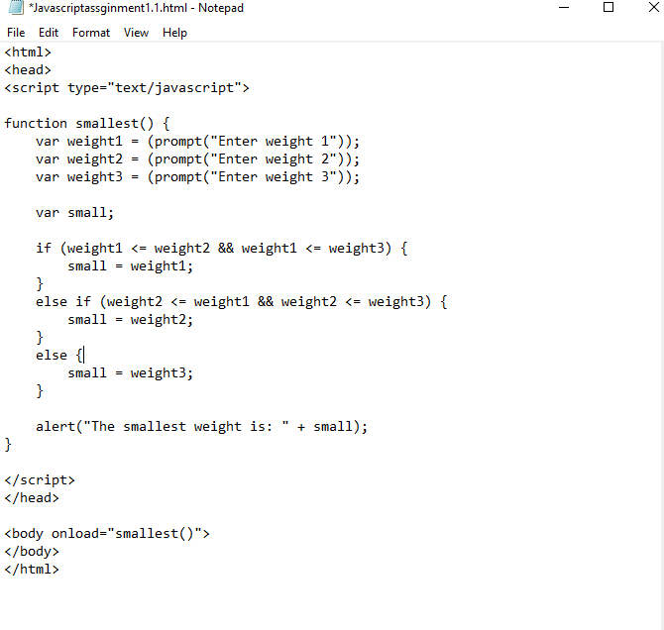

CC

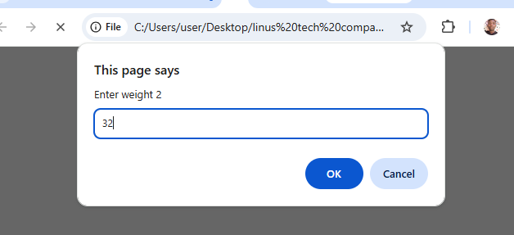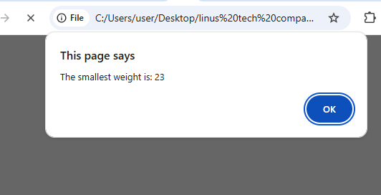S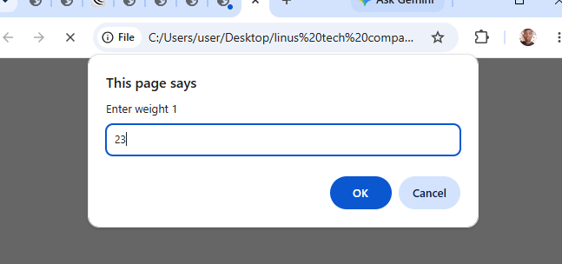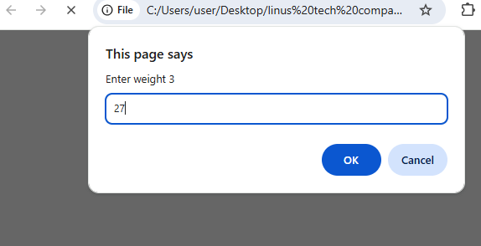CC

